Contents

Configuration 1

Configure the script: 2

Configure the modules: 2

Output 3

Example Summary: 3

Example Test Results Details: 3

# 

# Configuration

You will need to configure your script before you run it. The site specific information will need to be updated, and you will need to select which testing modules to run.

## Configure the Script:

There are 2 ways to run the script. You can scan a list of computers, or scan an Active Directory Org Unit.

Open ‘run-modules-[versionDate].ps1’ PowerShell ISE (as Admin).

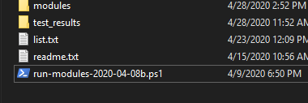

Find the ‘Config’ region in the script:

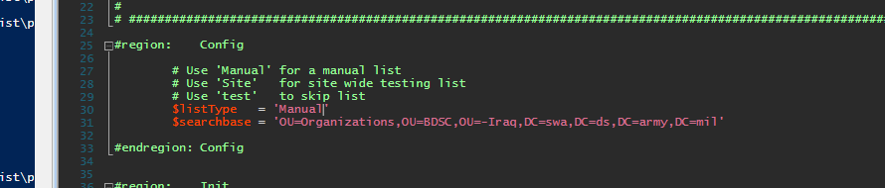

Set the ‘$listTtype’ variable to either ‘Manual’ or ‘Site’ to change the targets of the scanner.

Using ‘Site’:

1. Set ‘$listTtype’ to ‘Site’
2. Open your site OU in Active Directory and copy the ‘distinguishedName’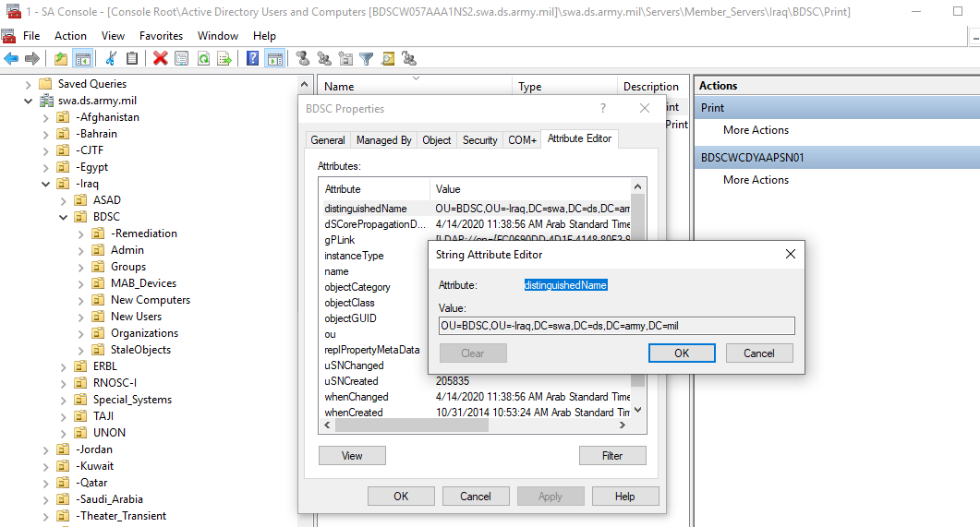
3. Paste your site OU ‘distinguishedName’ into the $searchbase variable to allow for site wide scanning.

Using ‘Manual’:

1. Set ‘$listTtype’ to ‘Manual’
2. The script will open notepad for you.
3. Paste in a list of computer names

## Configure the Modules:

Open the ‘modules’ folder and move the modules that you want exclude into the ‘not running’ folder.

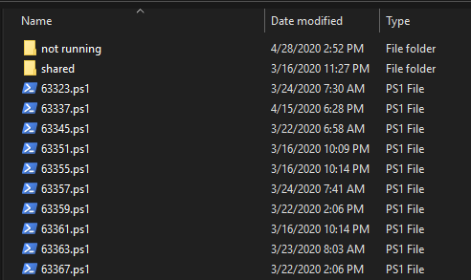

The ‘shared’ folder contains shared functions, such as the csv export function.

Once you have configured the modules and the script, run the script. The completion time depends on how many computers, and how many Vul IDs you are testing. Some tests take longer than others. It could take anywhere from 10 minutes, to 4 hours. Testing all computers and all Vul IDs at once will take considerable time; start the scan before leaving the office on a night where computers will not be restarted. The reports should be available in the morning.

# Output

The script will output a summary table of computers and the tests that were ran. If a test fails, the ‘test_results’ folder will contain the detailed results.

## Example Summary:

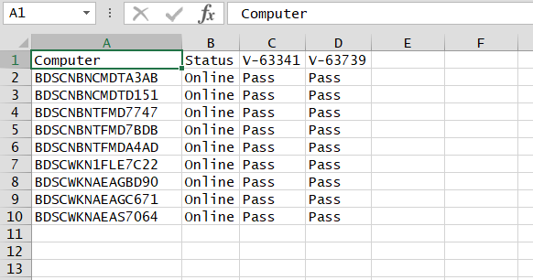

## Example Test Results Details:

Legend:

CheckValue The values that are stipulated by the STIG.   
Value The value that is returned by the scan.

‘CheckValue’ is compared to ‘Value’, if they are the same, the test is a pass